**REGULAR CLASSES**

**Adult Clay & Pottery Studio**

**Mon & Wed 9 AM–12, Mon & Wed 6:30–9 PM**

Hand building or wheel throwing. Beginners welcome. Materials and firing included.

Cost: $15 member/$20 non-member

**Instructors: AM - Sherry Cooler 850-496-6137.**

**Monday PM - Marcy Eady 850-585-4967**.

**Wednesday PM – Kat Cook 850-902-0388**.

Please call instructor of class you are interested in for seating availability in advance.

**Art Classes for Children Ages 6-12**

**Tues 4–5:30 PM**

**Monthly rate/ Due beginning of the month**

Cost per month: $60 member / $70 non-member

The students will learn basic drawing, painting, and sculpture. All supplies included.

Instructors: **Marcy Eady and Sharon Wnetrzak**

**Pastels and more with Vincent Zingaretti**

**Thursdays, 9am - 12**

Create Art with Vince. See Reverse

**Clay With Purpose - Adults**

**4th Saturday of the month, 9 AM-11:30 PM**

Instructor: Marcy Eady See reverse.

**Sip & Paint (Clay Studio)**

**3rd Thursday of the month, unless otherwise stated 6:30 PM-8:30 PM** See reverse.

**ADSO Photo Shooters Club**

Group meets twice a month on Zoom or at a photo shoot previously announced. Photographers of all levels are welcome! Attendance is free. Please email [jim.eustace@att.net](mailto:jim.eustace@att.net) for activities schedule.

**Life Drawing / Life Painting**

**2nd Saturday of the month**

**9 AM–12 PM and 1-4 PM**

Open session - no instructor. See reverse.

**Animal Portraits in Acrylic**

**Instructor: Nicolaus Seegel**

**3rd Saturday, 1-3:30 PM** See reverse.



Description: facebook

**Arts & Design Society of FWB**



**adso2958**

***Special Thanks to our Sponsors:***

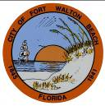

**City of Fort Walton Beach**

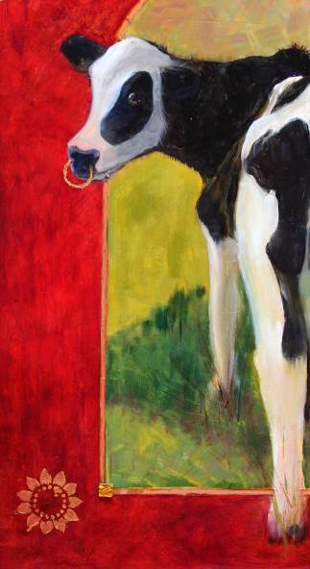

**Northwest Florida Ballet**



**Okaloosa Public Arts**



**17 First St. SE, Ft Walton Beach, FL 32548**

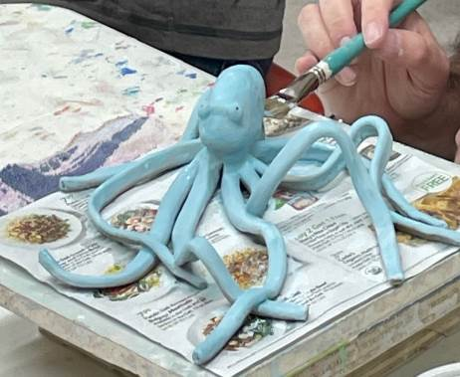**850-244-1271 adso@artsdesignsociety.org**

**www.artsdesignsociety.org**

**Office Tuesday-Friday 12 – 4 PM**

**Gallery Tuesday-Friday 12 – 4 PM,**

**Saturday 1 – 4 PM**

**Closed Monday and Sunday**

**APRIL 2024**

**CLASSES & WORKSHOPS**

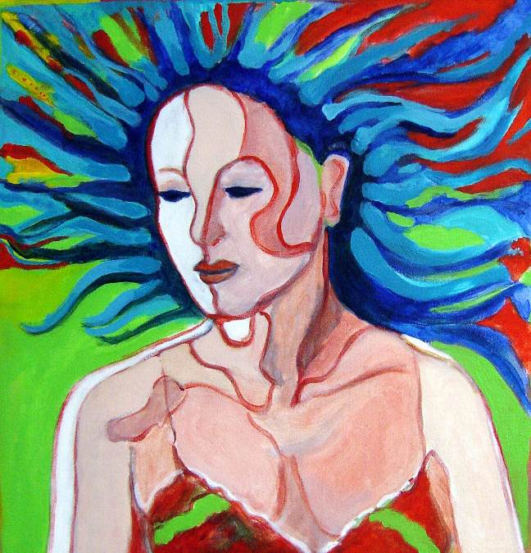

**APRIL**

**CLASSES & WORKSHOPS**

**FOR ADULTS**

All classes need to be paid for in advance.

**Lion or Bear Sculptures in Clay featuring figurative sculptor Kim Bernadas** Saturday April 6 and Sunday April 7 10am – 4 pm. Cost for mem. $250/ non-mem. $280, all supplies and firing included. Come join in the fun and explore your creativity in clay! Kim will provide detailed photographs,3D reference sculptures, as well as other details to create  the animals of choice. All levels welcome! Each student will have a completed sculpture ready for firing by the end of the workshop.

**Soft Pastels and More with Vincent Zingaretti**

**Thursdays in April, 9am - 12**

Cost is $30 mem,$35 non-mem. weekly or $100 mem/ $120 non-mem monthly.For All Levels, beginners on up. Create art with Vince by drawing, painting with soft pastels and/or oils. Students will bring their own painting supplies, though there will be lots of pastels to use. Bring a photo of what you would like to paint.

**Life Drawing /Painting– No instruction**

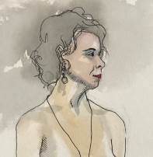**Saturday, April 13, 9 AM-12 PM short pose, 1-4 PM long pose** Open session - no instructor. Students bring their own materials and work from the model in any drawing or painting media (no photography is allowed). Cost: $15 per single session. For further information, or to sign up for an upcoming session, contact Lizzie Williams (850) 830-1055.

**Sip and Paint with Pat Roberts**

**Thursday, April 19, 6:30-8:30**

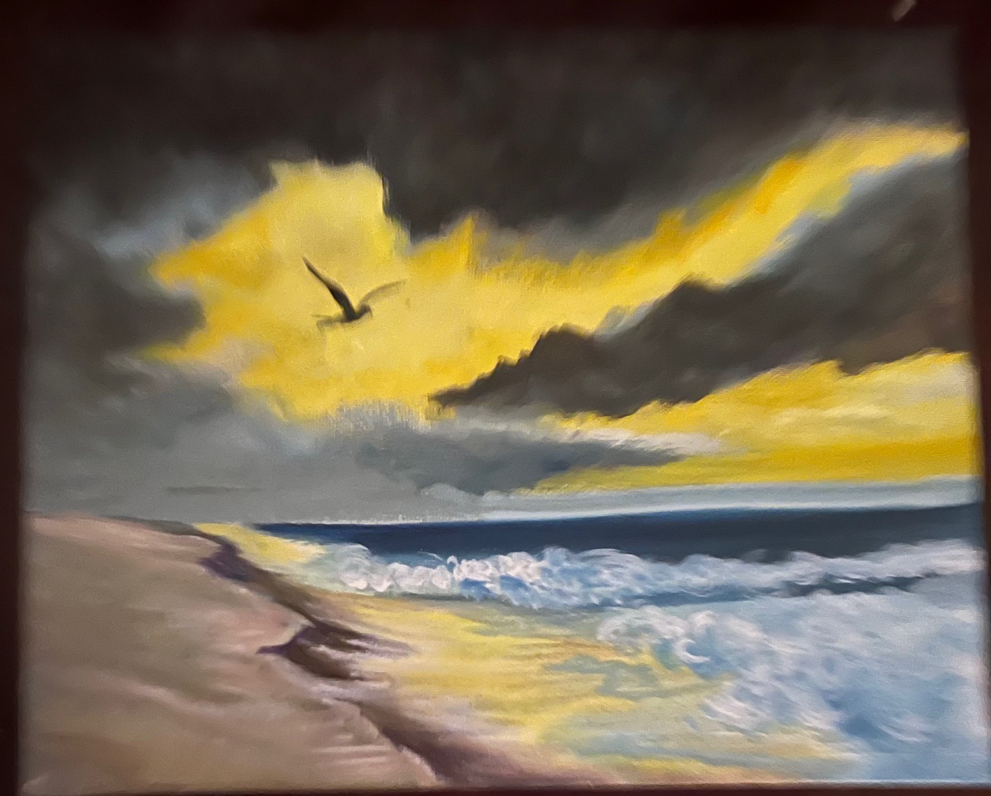Cost: $35 mem. / $40 non-mem.

All supplies included.

Students may bring a beverage of their choice to enjoy while learning or expanding their skills in Acrylics.

**Fox Portrait in Acrylics with Nicolaus Seegel**

**Saturday, April 20, 1-3:30 PM**

Cost: $60 member / $65 non-member

Level: Beginner / Advanced . In this class we will go over basic acrylic portraiture, exploring various brushes and techniques to create a realism style fox portrait on a 11x14 pre-sketched canvas. Students should bring a variety of acrylic brushes, all other supplies included.

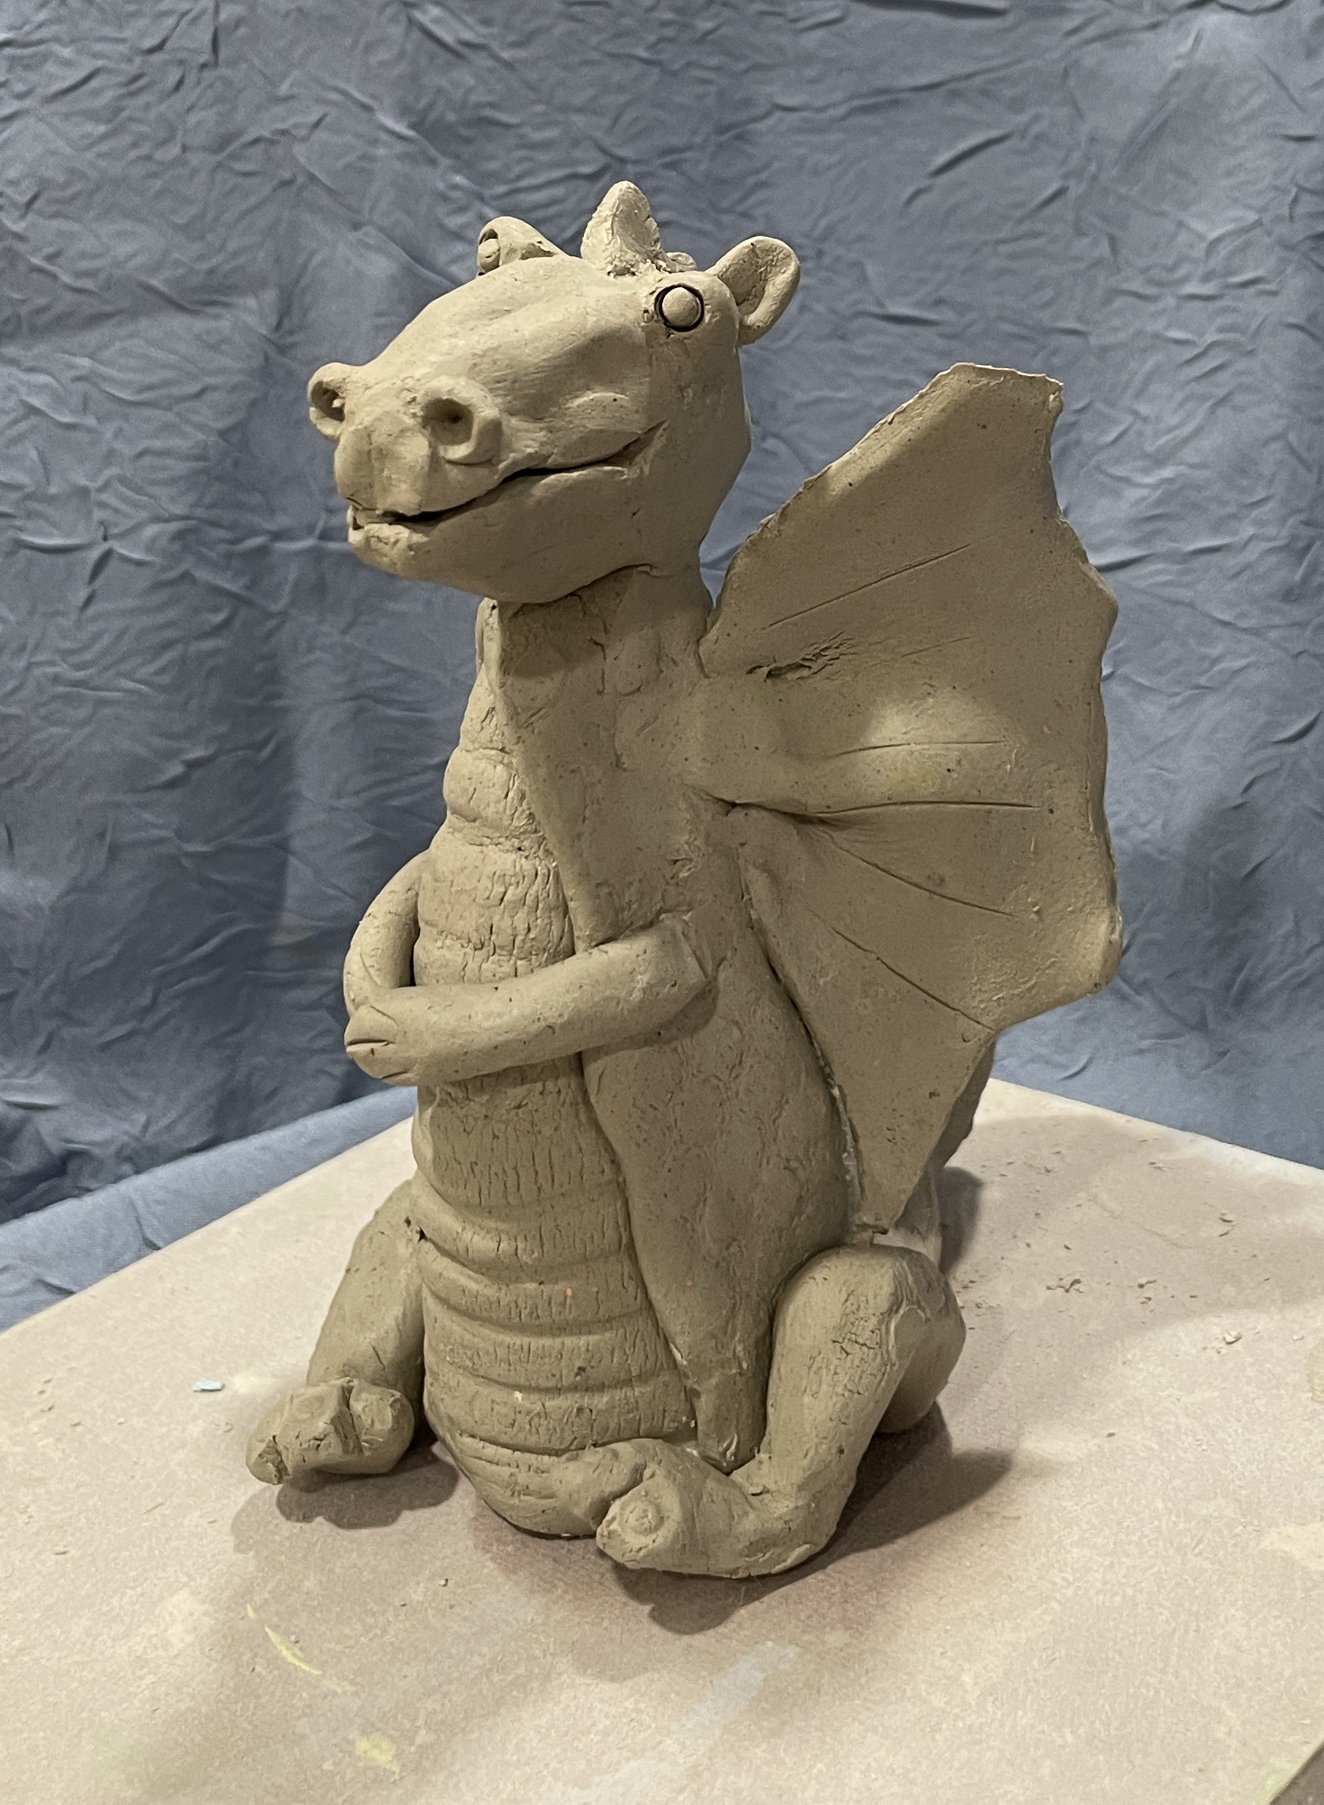**Clay With a Purpose with Marcy Eady**

**Saturday, April 27, 9-11:30** Cost $30 member / $35 non-member

Level: beginner/Advanced

All materials and firing are included. We will be making these cute little dragons. You will learn how make the dragon with all the fun parts needed, then we will glaze them. It will be fired and ready to take home in about a week.

**May**

**Acrylic with Carol Ann Cain**

**Friday and Saturday, May 3 and 4**

Cost: $95 for members & $105 for non-members.

We will be creating two paintings, using the same resource material for both paintings during the two-day workshop. One will be a painting using loosely controlled brushstrokes, while concentrating on the elements of design and atmosphere. The second will incorporate the previous lesson, while considering playfulness and intuition to create an abstract design, all while maintaining discipline and thoughtful decision-making. I will ask questions and make suggestive remarks to help spark the creative spirit during the second painting.

To sign up for any of these classes call our office Tue-Fri 12-4 PM, 850-244-1271.